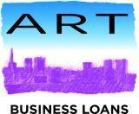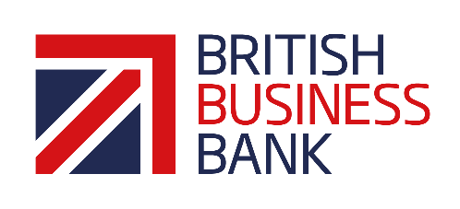

ART Business Loans Standard Terms and Conditions
Coronavirus Business Interruption Loan Scheme

Eligibility

- The loan is available to limited companies, sole traders, partnerships and social enterprises
- All applicants must have been declined by their bank for some or all of their required funding
- Most sectors will be considered where there is no CBIL scheme reason to exclude
- Must be West Midlands based in its business activity with an annual turnover of no more than £45m
- Your CBILS-backed facility will be used to support primarily trading in the UK
- Your business must generate more than 50% of its turnover from trading activity
- Have a borrowing proposal which, were it not for the COVID-19 pandemic, would be considered viable by the lender, and for which the lender believes the provision of finance will enable the business to trade out of any short-to-medium term difficulty

Location

- The business must be in the West Midlands

Amount and Term

- Loans are available between £10,000 to £150,000
- Loans are advanced for periods from 12 months to 6 years.
- There are no penalties for early repayment
- A capital holiday may be offered at our discretion.

Interest Rate

- Interest will be paid by the Government for the first 12 months of the facility
- Loans will be charged at the Bank of England base rate + 12%.

Fees

- Any arrangement fee will be paid by the Government

Security

- Personal Guarantees are not required
- All business assets to be pledged as security where appropriate

Application Procedure
- Applications must be made on the standard ART application form

